Carter Physiotherapy PLLC. Payment Receipt
2700 Bee Caves Rd. Ste. 111
Austin, TX. 78746
Location of Services: Outpatient Clinic (stand alone), code = 11
EIN: 27-11_______
Ph: 512-9______

Patient:

ICD9 Code:

Date Description Procedure Charge
Manual Therapy x 3 ($30/unit) 97140 90.00
Therapeutic Exercise ($30/unit) 97110 30.00

Total Charges: $120.00
Provider Discount: $
Total Payments: $
Account Balance: $

Provider:
Jarod Carter PT, DPT
License#: TX 116_____
NPI#: 144______

Provider Signature: 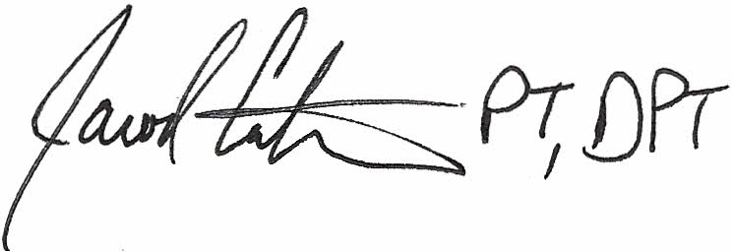

This patient has paid in full for the service provided and Carter Physiotherapy is NOT an insurance provider for this claim. PLEASE PROVIDE ANY PAYMENT DIRECTLY TO THE PATIENT

